Decision making on Unit Tests

Writing “Unit Tests” is a good thing. “Unit Tests” has its own benefits and allow us to develop testable systems. However writing bad Unit Tests and/or unnecessary Unit Tests can lead us to high cost, high maintenance software.

Regardless of whether you are a TDD practitioner, or a non-TDD practitioner, it is important that you write necessary Unit Tests. The more code means more maintenances. Similarly, the more Unit Tests means more maintenance.

So how would you decide, what Unit Tests to write and still ensure you provide an optimal quality to the software?

Here are some tips to follow.

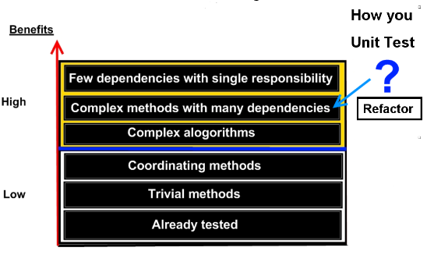

Already tested:
Whenever you write Unit Tests, be mindful that you do not write tests for the components that are already tested by other frameworks. You do not achieve any benefits at all.

Trivial methods:
There are methods, often very simple and easily understood. From design or requirement point of view there is nothing important in these methods. You do not gain any benefits for writing Unit Tests on these methods.

Coordinating methods:
Methods that do nothing but just calling lot of other methods are often time consuming to Unit Tests. You may also find these methods have no contribution to the design at all. Therefore, you do not achieve much benefits on Unit Testing these methods.

Complex algorithms:
Depending on your system, these methods may require Unit Testing. However it is not an easy task if the methods are really complex. My next topic describes a tool called Pex, which may assist you to Unit Test these methods.

Complex methods with many dependencies:
Sometimes you come across with these types of methods, which are not really easy to Unit Test due to the complexity and dependencies. Try to avoid these God methods. If not possible then consider re factoring so they can be Unit Tested.

Few dependencies with single responsibility:
These methods are prime candidates for Unit Testing. If the method is primarily designed to implement a requirement or a testable design decision, then you get optimal benefits out of your Unit Test.

Research Tools

Microsoft Pex
An automated testing tool developed by Microsoft Research. It allows you to do White Box testing while achieving higher code coverage.

You can download Pex from Microsoft Research. Pex is also included part of VS2010 Power Tools.

Pex will generate all the necessary inputs and outputs by looking at your method. Then you can generate Unit Tests and run them as required. I highly recommend for methods with complex algorithms. You can also use Pex with other Unit Test frameworks such as nUnit, xUnit.

When you download Pex, it comes with another tool called Moles, which allows you to replace any method with a delegate at test time.

You can download Pex from here.

CHESS
Another useful tool developed by Microsoft Research, which allows you to find and reproduce bugs (Heisenbugs)
in concurrent and multithreaded programs. CHESS supports testing both managed and unmanaged code.

How CHESS track bugs?
In a nutshell, CHESS repeatedly exercise/run each threads multiple times with different interleaving. If the interleaving result an error CHESS will allow you to debug the error.

You can make aware of your Unit Test that CHESS is integrated by just specifying the attribute, for example

[TestMethod]
[HostType(“Chess”)]
public void MyConcurrentThreadTestMethod()
{
……
}

CHESS allows you to locate the bug, reproduce it consistently, and then allow you to debug the issue.

